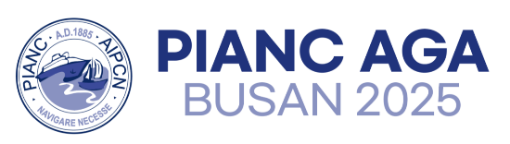 | EXHIBITION APPLICATION FORM
May 13(Tue.) ~ 16(Fri.), 2025
BPEX (Busan Port International Exhibition & Convention Center)
Please submit the participating company's logo(AI) and completed application form via e-mail(info@pianc-aga2025.kr) by April 18(Fri.).

1 | REGISTRATION INFORMATION

Company  / Organization | Name | (Name)
 | Address | (Address)
 | Phone | (Phone)
 | Website | (Website)
Point of  Contact | Name | (Name)
 | Title/Position | (Title/Position)
 | Phone | (Phone)
 | E-mail | (E-mail)

2 | EXHIBIT ITEMS

Exhibit Items | (Items) | (Details)

3 | METHOD OF PAYMENT

Participation Fee | KRW 1,500,000 (per booth, including VAT)

*Please note that the Participation Fee can only be paid via Bank Transfer.
*The Account Information will be sent via email after the Application Form is received.
*An Invoice will be sent to the email within a week of submitting this Application Form.

Authorized Signature ______________ Date ______________

